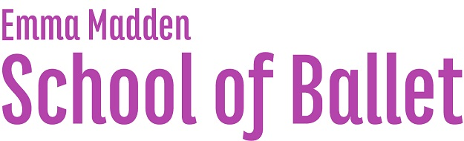 | www.knocklyonballet.ie  www.firehouseballet.ie  www.emmamaddenballet.ie  +353 879133816

WELCOME TO EMMA MADDEN SCHOOL OF BALLET REGISTRATION

To secure your place with us please return this form signed with fee transfer paid referencing students name. Please note that ALL term fees are payable in advance of each term. Each term has 10 classes and prices are as follows:

- €85 for 30/45 minute classes
- €90 for 1 hour classes
- €150 for 2 siblings from the same family
- €200 for 3 siblings from the same family

UNIFORMS
The school's IDTA uniform can be ordered directly through the school. There will be an opportunity to try sizes on the first week of each month. Please notify us by text in advance if you would like to order a uniform. Prices are as follows:

- Lilac IDTA leotard w/ skirt €33
- White Crossover cardigan €12
- Pink Leather Ballet Shoes €10 (can also be bought from Danceworld Ranelagh/Parnell Street)
- Pink Ballet Tights €6

WE HAVE NEW BANK DETAILS
- Emma Madden
- BIC: BOFIIE2DXXXXXX
- IBAN: IE59BOFI90020122597258
- (Please reference each transfer with the student’s full name.)

We update our Facebook page frequently so don’t forget to follow us and give us a like!  www.facebook.com/EmmaMaddenBallet.ie | 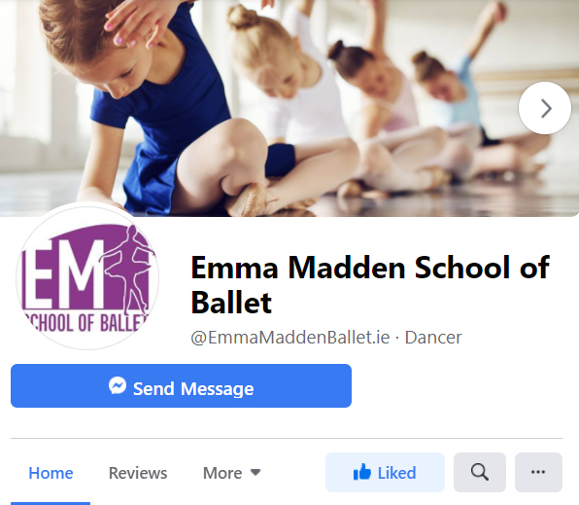

www.knocklyonballet.ie
www.firehouseballet.ie
www.emmamaddenballet.ie
+353 879133816

REGISTRATION FORM

Student Name |  | Date of Birth |  | Age

Class Venue |  | Class Time

Parent/Guardian Name |  | Contact Number(s)

Address

Email Address

Relevant Medical Information

Where did you hear about us?

www.knocklyonballet.ie
www.firehouseballet.ie
www.emmamaddenballet.ie
+353 879133816

PUBLICATIONS CONSENT
Emma Madden School of Ballet occasionally posts update images of our work in class, rehearsals, performances and exams. These updates can be found on our Facebook page, Instagram account and website. If you wish your child NOT to be included in these updates please text me informing me of this decision on 0879133816. By registering with our school you are agreeing to be included in any end of year performance being professionally recorded for distribution to students partaking in said performance.

GDPR CONSENT

What information will I be asked to provide upon registration for Emma Madden School of Ballet?
Information including Student Name, Parent Name, Date of Birth, Age, Postal & Email address and information surrounding relevant medical conditions are collected for the purpose of contact and registration. Emma Madden of Emma Madden School of Ballet has access to this information.

What will my information be used for?
Information provided is used for contact purposes about classes, examinations, performances, date/time changes for class, medical emergencies or other information directly relating to your child and the running of the school. All information collected is never shared with any third party.

How long will my information be held?
Information is held while each student remains a student with the school.

I have read the above statement and am happy to proceed with registration for my child into Emma Madden School of Ballet.

Student Name: |  | Parent/Guardian Name:

Parent/Guardian Signature: |  | Date:

